Development of a data fusion model for detection of electronic components and generating of a life-cycle inventory PCB model

BY

Bernhard Föllmer

Department of Machine Tools and Factory Management

Chair of Industrial Information Technology

Submitted in partial fulfillment of the requirements

for the degree of

Master of Science in

Physical Engineering Science

at the

Technical University of Berlin

13.10.2014

Contents

[List of figures 6](#_Toc402708742)

[List of tables 7](#_Toc402708743)

[Abbreviations 8](#_Toc402708744)

[1. Introduction 9](#_Toc402708745)

[1.1 Object recognition from 2D Images 9](#_Toc402708746)

[1.1 Recycling potential of electronic waste 9](#_Toc402708747)

[2. Recognition of electronic components 9](#_Toc402708748)

[2.1 Data fusion model 9](#_Toc402708749)

[2.2 Image preprocessing 9](#_Toc402708750)

[2.2.1 Image rotation correction 9](#_Toc402708751)

[2.2.2 Scaling determination based on scaling symbol 12](#_Toc402708752)

[2.3 Electronic component detection 17](#_Toc402708753)

[2.3.1 Electronic component detection based on color based background detection 17](#_Toc402708754)

[2.3.2 Electronic component detection based on 3D range image 17](#_Toc402708755)

[2.3.3 Electronic component detection based on normalized correlation 17](#_Toc402708756)

[2.4 Feature extraction algorithms for electronic components 17](#_Toc402708757)

[2.4.1 Image resolution for feature extraction 17](#_Toc402708758)

[1.1.1 Fourier coefficients based feature extraction 19](#_Toc402708759)

[1.1.2 Histogram based feature extraction 21](#_Toc402708760)

[1.1.3 Segment based feature extraction 22](#_Toc402708761)

[1.1.4 PCA reconstruction error based feature extraction 24](#_Toc402708762)

[1.2 Feature selection and feature fusion techniques for classification 28](#_Toc402708763)

[1.2.1 Introduction to feature selection 28](#_Toc402708764)

[1.2.2 Fisher score 28](#_Toc402708765)

[1.2.3 Random forest feature selection 28](#_Toc402708766)

[1.2.4 Survey of the most important features 28](#_Toc402708767)

[2. Classification 28](#_Toc402708768)

[2.1 Random forest classifier 28](#_Toc402708769)

[2.2 Support vector machine classifier 28](#_Toc402708770)

[3. Decision fusion for component recognition 28](#_Toc402708771)

[4. Optical character recognition of electronic component marking 29](#_Toc402708772)

[4.1 Introduction 29](#_Toc402708773)

[4.2 Character segmentation 29](#_Toc402708774)

[4.3 Optical character recognition with Tesseract and Cognex Vision Pro software 29](#_Toc402708775)

[4.4 Electronic part label verification based on Octopart database 29](#_Toc402708776)

[5. Experimental results 29](#_Toc402708777)

[5.1 Implementation 29](#_Toc402708778)

[5.2 Dataset creation 30](#_Toc402708779)

[5.2.1 Image acquisition 33](#_Toc402708780)

[5.3 Classification results 34](#_Toc402708781)

[5.4 Optical character recognition results 34](#_Toc402708782)

[6. Life-cycle inventory analyses of printed circuit boards 34](#_Toc402708783)

[6.1 Introduction 34](#_Toc402708784)

[6.2 Printed circuit board region classification based on electronic part recognition results 34](#_Toc402708785)

[6.3 GaBi-Software and LCI data availability of electronic components 34](#_Toc402708786)

[6.4 ILCD format for LCA-data exchange 34](#_Toc402708787)

[7. Conclusion and prospects 35](#_Toc402708788)

[7.1 Real time PCB board inspection 35](#_Toc402708789)

[7.2 Feature extraction based on Wavelet basis functions 35](#_Toc402708790)

[Appendix A 35](#_Toc402708791)

# List of figures

[Figure 1: Image rotation correction process 10](#_Toc402708792)

[Figure 2: Image rotated by 3.0 degree 11](#_Toc402708793)

[Figure 3: Canny edge image of the rotated image 11](#_Toc402708794)

[Figure 4: Shifted DFT of the rotated image (logarithmic representation) 11](#_Toc402708795)

[Figure 5: Summed amplitude over angle (invariants by 90 degree) 12](#_Toc402708796)

[Figure 6: Scale symbol 13](#_Toc402708797)

[Figure 7: Scale symbol placed on the board 13](#_Toc402708798)

[Figure 8: Scaling determination process 14](#_Toc402708799)

[Figure 9: Value channel (brightness) of HSV color image 16](#_Toc402708800)

[Figure 10: Cosine transform filtered image 16](#_Toc402708801)

[Figure 11: Otsu thresholding 16](#_Toc402708802)

[Figure 12: Blobs of the scaling symbol 16](#_Toc402708803)

[Figure 13: Image resolution 19](#_Toc402708804)

[Figure 14: DIP14 package with equidistant solder joints 20](#_Toc402708805)

[Figure 15: Tantalum capacitor in RGB color model (left) and HSV color model (right) 22](#_Toc402708806)

[Figure 16: Normalized histogram of hue channel (tantalum capacitor) 22](#_Toc402708807)

[Figure 17: Normalized histogram of saturation channel (tantalum capacitor) 22](#_Toc402708808)

[Figure 18: Normalized histogram of value channel (tantalum capacitor) 22](#_Toc402708809)

[Figure 19: DIP14 (top, left), DIP14 edge image (top, right), DIP14 reconstruction with component PCs (middle, left), DIP14 reconstruction with non-component PCs (middle, right), unit matrix projection into component PCs (bottom, left), unit matrix projection into non-component PCs (bottom, right) 26](#_Toc402708810)

[Figure 20: PCA feature construction process 27](#_Toc402708811)

[Figure 21: Component border definition 32](#_Toc402708812)

[Figure 22: Database section 32](#_Toc402708813)

[Figure 23: Image acquisition system 33](#_Toc402708814)

# List of tables

[Table 1: Feature extraction algorithm based resolution parameter 18](#_Toc402708815)

[Table 2: Component properties 30](#_Toc402708816)

[Table 3: Components in database 35](#_Toc402708817)

# Abbreviations

DFT

Discrete fourier transform, 10

FFT

Fast fourier transform, 10

LoG

Laplacian of Gaussion, 31

# Introduction

ewt

## Object recognition from 2D Images

Dg

## Recycling potential of electronic waste

Asd

# Recognition of electronic components

Erdt

## Data fusion model

Saf

## Image preprocessing

S

Asf

### Image rotation correction

To bypass the restriction of rotation invariant features for object recognition, the rotation angle of the printed circuit board images were determined. Since there is no fixed printed circuit board orientation, the orientation is set by invariants of 90 degree whereas most of the electronic parts are horizontal or vertical alligned. The whole process is based on the assumption that Conducter tracks and electronic parts are mostly horizontal or vertical aligned and there structure and borders producing more horizontal and vertical edges than edges with different orientations. The rotation angle estimation is based on the rotation property of a discrete Fourier transform. The DFT of an image rotated by and angle Θ is the DFT of the unrotated image, rotated by the same angle Θ. The rotation property of a DFT is derived in (Maria Petrou, Costas Petrou, 2010) and therefore omitted here. The image rotation correction process is shown in Figure 1.



Figure : Image rotation correction process

At first the Image is cropped to a squared image [2000 x 2000] to reduce the process runtime. The RGB image is converted to grayscaled image and canny edge detection is applied. Afterward a 2D DFT is computed from the edge image. To estimate the rotation angle, the amplitude of the shifted 2D FFT image is summed up over discretized angles and normalized by number of amplitudes per angle step. The discretization is done in steps of 0.25 degree from 0 to 360 degree which results in a discretization error of 0.125 degree. The maximum of the normalized sum of amplitudes over the angle corresponds to the image rotation angle. With this process the rotation angle can be estimated with invariants of 90 degree image rotation. An example of a rotated image by 3 degree, the edge image and amplitude of discrete Fourier transform is shown in Figure 2, Figure 3 and Figure 4. The accuracy of the angle estimation was not investigated in detail but inaccuracy could not be determined by eye.

|  |  |
| --- | --- |
| C:\Users\WIN\Masterthesis\Masterthesis\Masterarbeit_daten\2.2.1\rot1.png  Figure : Image rotated by 3.0 degree | C:\Users\WIN\Masterthesis\Masterthesis\Masterarbeit_daten\2.2.1\rot3.png  Figure : Canny edge image of the rotated image |
| C:\Users\WIN\Masterthesis\Masterthesis\Masterarbeit_daten\2.2.1\rot2.png  Figure : Shifted DFT of the rotated image (logarithmic representation) |  |



Figure : Summed amplitude over angle (invariants by 90 degree)

* Linien werdan auf punkte abgebildet

### Scaling determination based on scaling symbol

To bypass the restriction of scale invariant features for object recognition, the scaling of the printed circuit board images were determined using a scaling symbol.



Figure : Scale symbol

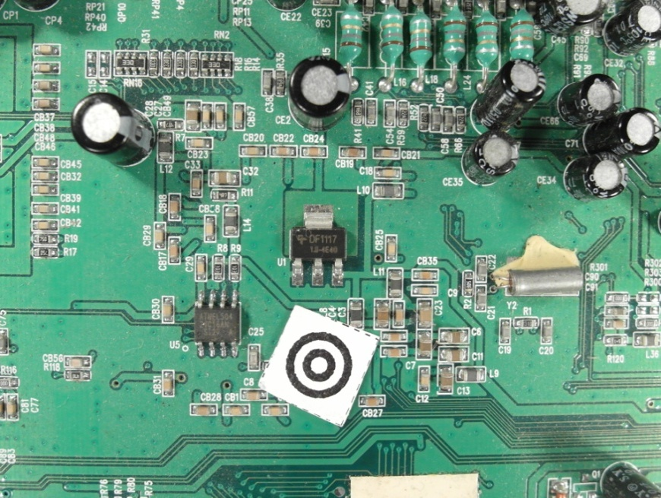

Figure : Scale symbol placed on the board

The scaling symbol is shown in Figure 6. The whole scaling determination process is shown in Figure 8.



Figure : Scaling determination process

At first the image is converted from the RGB color model to the HSV color model and the brightness channel (value channel) is used to make a discrete cosine transform. The discrete cosine transform is frequently used in image compression such as the JPEG format. The discrete cosine transform is similar to the discrete Fourier transform but uses only cosine functions as kernels. The discrete cosine transform is shown in Equation (1) and (2) (Rafael C.Gonzalez, 2008).

|  |  |
| --- | --- |
|  | () |
|  | () |

|  |  |
| --- | --- |
|  | () |

To suppress illumination changes, an ideal low pass filter is applied in the frequency domain in which the first 10 x 10 cosine coefficients were discarded. Afterwards the inverse cosine transform is applied to get the image in time-domain. To extract the two dark circles of the scaling symbol, Otsu’s method is used to automatically perform thresholding. To avoid salt and pepper noise, a morphological closing operator (5x5) is applied. The image is inverted and the eccentricity and bounding boxes are determined of the blobs. All blobs inside the eccentricity interval and inside the diameter interval are maintained, all others are discarded.

|  |  |
| --- | --- |
| } | () |

* eccentrcity min angeben

To find the center of the scaling symbol, the distances between the centers of all blobs are calculated and the two blobs with the smallest distance are the inner and outer dark rings of the scaling symbol. The outer diameter of the larger blob is used as reference to calculate the image scale.

|  |  |
| --- | --- |
|  | () |

|  |  |
| --- | --- |
| C:\Users\WIN\Masterthesis\Masterthesis\Masterarbeit_daten\2.2.2\scale5.png  Figure : Value channel (brightness) of HSV color image | Figure : Cosine transform filtered image |
| Figure : Otsu thresholding | C:\Users\WIN\Masterthesis\Masterthesis\Masterarbeit_daten\2.2.2\scale6.png  Figure : Blobs of the scaling symbol |

## Electronic component detection

Asdsad

### Electronic component detection based on color based background detection

Sdf

### Electronic component detection based on 3D range image

Sd

### Electronic component detection based on normalized correlation

Sasd

## Feature extraction algorithms for electronic components

Sad

### Image resolution for feature extraction

The resulting features quality of feature extraction algorithms depend on the resolutions of the images. In general higher image resolutions improve the feature precision but also increase the run time and require more memory. Therefore a trade off between a high image resolution on one hand and memory usage and runtime on the other side must be found. In this approach the image resolution depends on the size of the component. Smaller components require a higher resolution than larger ones because there images contain more details.

- entropy

In this approach the resolution depends on the components area and the feature extraction algorithm.

|  |  |  |  |
| --- | --- | --- | --- |
| |  |  | | --- | --- | |  | () | |  |
| |  |  | | --- | --- | |  | () | |  |

The algorithm dependent resolution parameters are defined in Table 1.

Table : Feature extraction algorithm based resolution parameter

|  |  |  |  |
| --- | --- | --- | --- |
|  | a | b | c |
| Fourier coefficients based feature extraction | 5 | 0.003 | 15 |
| Histogram based feature extraction | 10 | 0.003 | 10 |
| Segment based feature extraction | 19 | 0.005 | 1 |
| PCA reconstruction based feature extraction | 18 | 0.005 | 2 |

The area and algorithm dependent resolution is plotted in Figure 13.

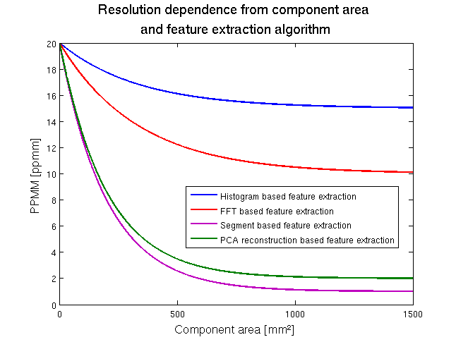

Figure : Image resolution

### Fourier coefficients based feature extraction

Every periodical infinite signal can be decomposed in ….

Fourier descriptors as features were used in already used in applications for face recognition and object recognition (Campos, 2000).

The idea to use Fourier coefficients as features comes from the representation of solder joints by most electronic component images. Many computer vision systems for solder join detection, localization and segmentation have been develop. Specular reflections of solder joint depending on small changes in viewing direction and different shape and size of the solder joints make it difficult to create a stable recognition system (Tianshoul, 2012). Many electronic components consist of several equidistant arranged solder joints. An example is the widely used DIP14 package seen in Figure 14. Since the solder joints appear in the grayscaled image as bright equidistant spots they should be representative frequencies in the 2D Fourier spectrum with the period around the solder joint distance.

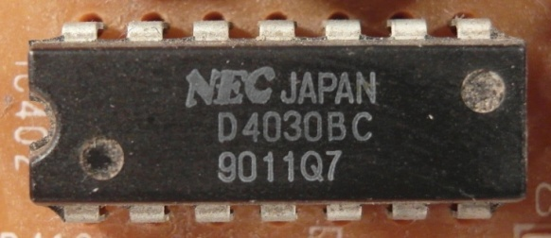

Figure : DIP14 package with equidistant solder joints

The 2D discrete Fourier transform for an M x N image is defined as

|  |  |
| --- | --- |
|  | () |

and where $f(x,y)$ is the image of size M x N (Rafael C.Gonzalez, 2008). The Fourier coefficients are in general complex numbers consisting of real and imaginary part. The real part represents the cosine and the imaginary the sinus proportion of the signal. The M x N image consists of M x N Fourier coefficients which produces 2 x M x N frequency features which is a large number of features that can be used. To increase execution time of the classifier and decrease recognition rate, a subset of low frequency features is extracted. Further research shows that spatial frequencies with lower frequency represent global information about the shape such as general orientation and proportion. The visual information is represente

Since the solder joints are the main focus for frequency feature, the solder joint distance of electronic components is used as a measure of minimal frequency period. In our feature extraction all Fourier coefficient (real and imaginary part) with a frequency under the cutoff frequency are used as features.

|  |  |
| --- | --- |
|  | () |

The numbers of features depend on the size of the component image.

|  |  |
| --- | --- |
|  | () |

Abtastthorem (+1)

Another interesting feature extraction based on wavelets could analyze frequencies and there temporal occurrence which could improve the classification results. A view on that topic was done in the prospective section 7.2.

* Energie in niedrigen frequnzen -> hohe information (paper)

### Histogram based feature extraction

Color image segmentation algorithms for automated optical inspection in electronics have already been investigated (Tarnawski, 2003). Electronic components varying in color, such as several tantalum capacitors, ICs or SMD electrolyte capacitors. To find representative features the color model has to be defined. In this system, the HSV (hue-saturation-value) color model was used because the channels are not that strong correlated such as in the RGB color model and relative stable against illumination changes or shadows (H. Cheng, H. Jiang, Y. Sun, Jingli Wang, 2000), (Noor. A. Ibraheem, Mokhtar M. Hasan, Refiqul Z. Khan, Pramod K. Mishra, 2012). Histogram based features are features which depend on the probability distribution of the pixels over the color values. In the histogram based feature extraction 10 equidistant bins are defined in each color channel (hue-saturation-value) and the pixel distributions are determined and normalized by the number of pixels. The values correspond to the probability density function of the gray value. All ten bin values are use as features that results in 30 color features. The histogram of a tantalum capacitor is seen in Figure 15, Figure 16, Figure 17 and Figure 18.

|  |  |
| --- | --- |
| C:\Users\WIN\Masterthesis\Masterthesis\Masterarbeit_daten\2.4.2\tantal.png  Figure : Tantalum capacitor in RGB color model (left) and HSV color model (right) | Figure : Normalized histogram of hue channel (tantalum capacitor) |
| Figure : Normalized histogram of saturation channel (tantalum capacitor) | Figure : Normalized histogram of value channel (tantalum capacitor) |

### Segment based feature extraction

The segment based feature extraction is based on the idea that electronic components can be identifies by striking color regions. One approach to extract information about spatial proximity of pixels is the region growing algorithm. The region growing starts with seed points which pixel position is the most important drawback.

In this feature extraction algorithm, the seed points are uniformly distributed over the part image. The region growing and feature extraction of the segments is done in HSV color space. The distance between the seed points depends on the size of the component which is based on the assumption that smaller components consist of smaller color regions than big components. The equation for the distances is specified in (11).

|  |  |
| --- | --- |
|  | () |
|  | () |

In the region growing segmentation approach the neighboring pixel of the seed pixel are added to the segment if the distance between the color of the seed point and the neighboring pixel is smaller than a certain value. Further the neighboring pixels of the new segment are added to the segment if their distance to the color mean of the segment is smaller than a certain value. This process is iterated until no more pixels are added to the new segment (Maria Petrou, Costas Petrou, 2010).

One example is the Multi-layer ceramic capacitor (MLCC) shown in .

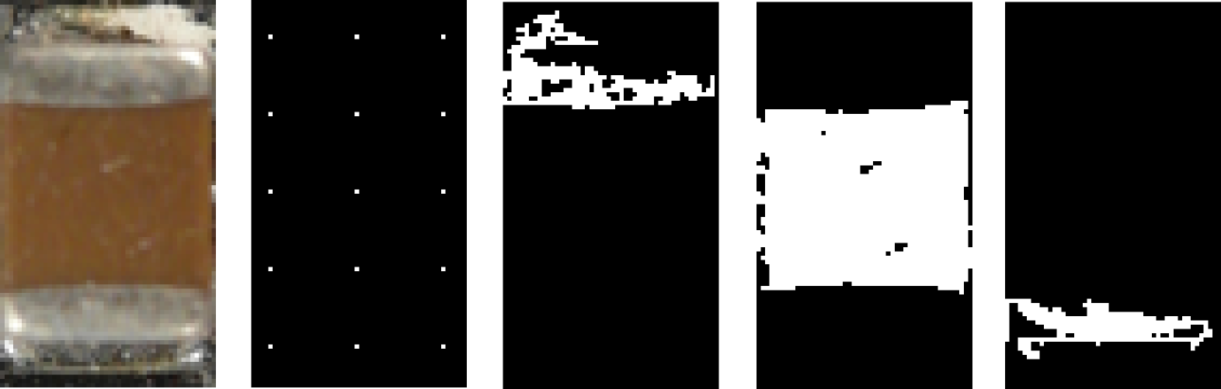

Seven Features are extracted for every segmented region which are the x-coordinate of center of gravity, y-coordinate of center of gravity, bounding box height, bounding box width and the arithmetic mean color value in all three color channels.

* Border to seeds in picture
* Formeln region growing

### PCA reconstruction error based feature extraction

Object detection based on image reconstruction with Principal Component Analyses was already applied for pedestrian recognition. (L. Malagón-Borja, Olac Fuentes, 2007). A similar approach was used to extract a PCA reconstruction feature. In that system the PCA reconstruction is based on edge images of the parts. At first a subset of the training images of parts are used to find principal components which can compress optimally only the kind of images that were used to compute the principal components.

#### Image reconstruction with PCA

A set of m part images $I_{i}$ each of size r x c is reshaped to a vectors $v_{i}$ of size r\*c x 1. First the mean vector **μ** and the covariance matrix **C** are computed for all vectors according to (13) and (14).

|  |  |
| --- | --- |
|  | () |
|  | () |

Next the eigenvectors and eigenvalues are computed and sorted according to decreasing eigenvalues. This computation can be done in several ways in which Matlab implementation based on the QZ algorithm was used in this approach. The eigenvectors $e_{i}$ with the k largest eigenvalues $λ_{i}$ of the covariance matrix are used to construct the projection matrix **P** of size r\*c x k. The projection of an image vector $v_{i}$ into the eigenspace is given by

|  |  |
| --- | --- |
|  | () |

The reconstruction of an image projects the image into the PCs and from this projection, try to recover the original image by applying the invers projection matrix. The projection and recover step is shown in whereas $v_{i}'$ is the reconstructed image of the image .

|  |  |
| --- | --- |
|  | () |

The reconstruction error is defined by the euclidean distance between the image $v_{i}$ and its reconstructed image .

|  |  |
| --- | --- |
|  | () |

Often there will be just a view large eigenvalues whose eigenvectors contain the most information while the rest of the dimensions generally contain noise (Duda, 2001).

#### PCA feature construction

A set of PCs from a set of images from one component reconstruct the images of the same component better than other types of images. The fact can be observed in the images in Figure 19 and can be used to create a feature which represents the difference between the reconstruction error of the projection into the component PCs and the non-component PCs.



Figure : DIP14 (top, left), DIP14 edge image (top, right), DIP14 reconstruction with component PCs (middle, left), DIP14 reconstruction with non-component PCs (middle, right), unit matrix projection into component PCs (bottom, left), unit matrix projection into non-component PCs (bottom, right)

In this approach the component images and non-component images are scaled according to the size of the component. After the RGB images are converted to grayscaled images and the image intensity values are adjusted for contrast improvement. To obtain a feature that contains information about the edges the edge image was created by applying a Laplacian of Gaussian (LoG) filter. The projection matrix $P_{ep}$ and the mean $μ_{ep}$ are computed from a subset of component images and the projection matrix $P_{en}$ and mean $μ_{en}$ for the non-component images are computed. The reconstruction based on the component PC projection is computed by (18) and the reconstruction based on the non-component PC projection is computed by (19).

|  |  |
| --- | --- |
|  | () |

|  |  |
| --- | --- |
|  | () |

The reconstruction error of component images projected by component PCs should be smaller for component images than non-component images. The features is the difference between the reconstruction error projected in the component PCs and the error projected in the non-component PCs shown in (20).

|  |  |
| --- | --- |
|  | () |

The process is shown in Figure 20.

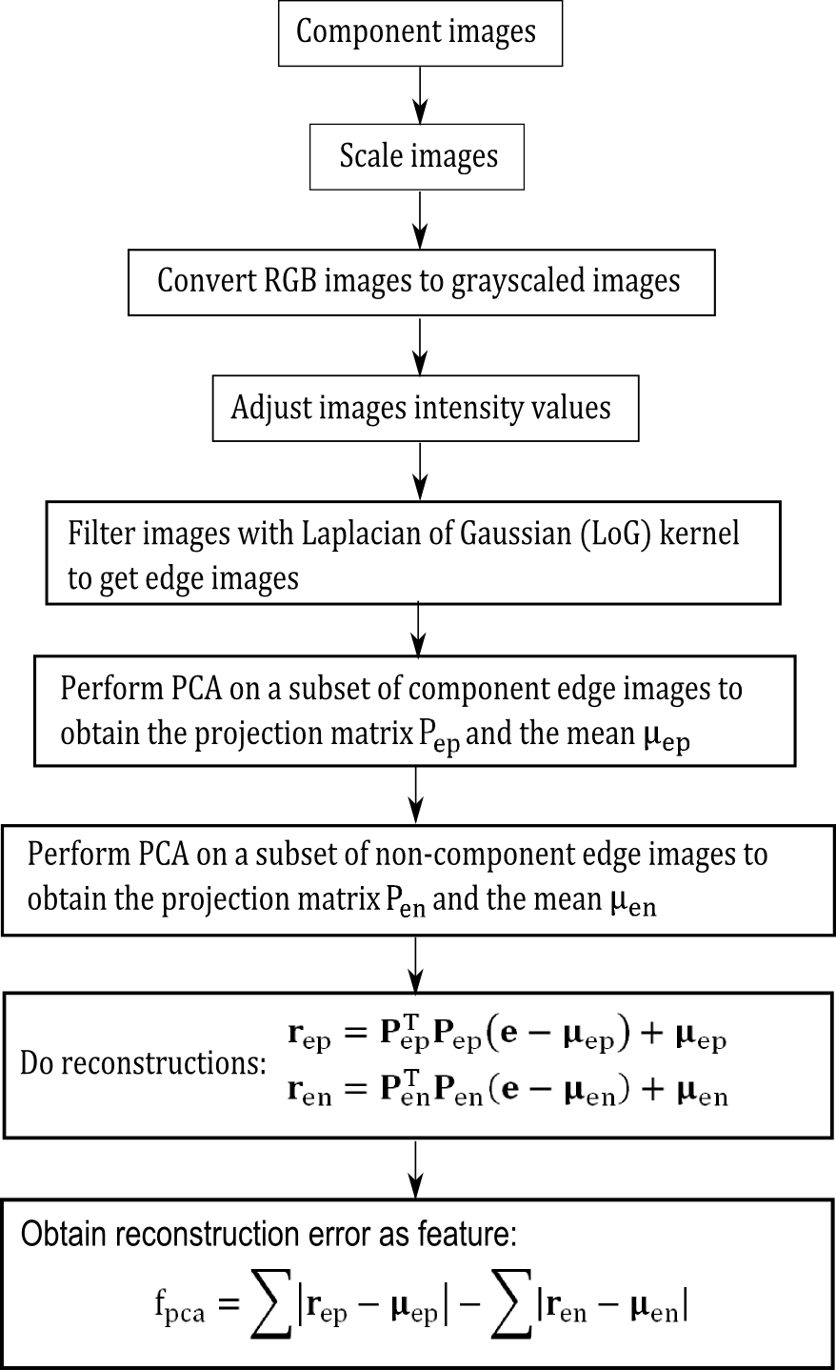

Figure : PCA feature construction process

## Feature selection and feature fusion techniques for classification

Asd

### Introduction to feature selection

Asd

* Wrapper, embedded
* Guyon

### Fisher score

Fisher score is a variable ranking method that rates the efficient for discriminations for each feature. It can be applied in two-class problems as well as in multi-class problems. The score evaluates each feature by the ration of the between class variance to the within-class variance (Guyen, 2003). Suppose we have a set of d-dimensional samples $x_{1}, {…,x}_{n}$, $n_{k}$ is the number of samples in the subset $D_{k}$ labeled $ω_{k}$ and c is the number of classes. The Fisher score of the $j$-th feature is computed in (21).

|  |  |
| --- | --- |
| $$F\left(x^{j}\right)=\frac{\sum_{k=1}^{c}{n_{k}{\left(μ_{k}^{j}-μ^{j}\right)}^{2}}}{{\left(σ^{j}\right)}^{2}})$$ | (21) |

Where $σ^{j}$ is the standard deviation and $μ^{j}$ the mean of the whole data set corresponding to the $j$-th feature and $x_{i}^{j}$ is the $j$-th feature of the sample $x_{i}$.

|  |  |
| --- | --- |
| $${\left(σ^{j}\right)}^{2}=\sum_{k=1}^{c}{n_{k}{\left(σ_{k}^{j}\right)}^{2}}$$ | (22) |
| $$σ_{k}^{j}=\sum_{x_{i}∈D_{k}}{x_{i}^{j}}-{\tilde{μ}}_{k}^{j}$$ | (23) |
| $${\tilde{μ}}_{k}^{j}=\frac{1}{n_{i}}\sum_{x_{i}∈D_{k}}{x_{i}^{j}}$$ | (24) |

|  |  |
| --- | --- |
|  | (25) |

After computing the fisher score for each feature, it selects the top-m features as the subset of features. The number of features m can be fixed or depend on a score threshold. The score of each feature is computed independently of all other features. Therefore the feature subset can be suboptimal because features with low individual scores but a very high score when they are combined are discarded furthermore redundant features are not discarded (Q. Gu, Z. Li, J. Han, 2012). In this approach the fisher score is only used in the two stage feature selection and not applied alone for feature selection (see chapter 2.5.4).

### Random forest feature selection

Asd

### Two stage feature selection

asf

### Survey of the most important features

dfg

# Classification

Asdf

## Random forest classifier

asd

## Support vector machine classifier

Asdf

# Decision fusion for component recognition

Asf

# Optical character recognition of electronic component marking

Dsf

## Introduction

Dsf

## Character segmentation

Dsf

## Optical character recognition with Tesseract and Cognex Vision Pro software

Asdf

## Electronic part label verification based on Octopart database

Dsf

# Experimental results

## Implementation

Asfd

## Dataset creation

The dataset consist of 12 electronic components which were analyzed. The components are listed in Appendix A. The component selection depends on the occurring frequency on the available printed circuit boards. It was taken care that also similar looking components were selected. Therefor the DIP14 component and DIP16 component which differ almost only by number and position of solder joints were selected. In addition the tantalum capacitors of different size but similar appearance were selected. For electronic component recognition, a machine learning application was used whereas multiple representation of the component must be created to analyze representative features. The component representations are taken from different parts of a component and different printed circuit boards to create a representative dataset. The available printed circuit boards are seen in .

To detect the edges of the parts, border pixels are also selected from the printed circuit board images. Additional important information and properties of the component are listed in.

Table : Component properties

|  |  |
| --- | --- |
| **Component properties** | **Description** |
| **Package properties** |  |
| Component length |  |
| Component width |  |
| Component border size |  |
| Package DOF |  |
|  |  |
| **OCR properties** |  |
| ROI for optical character recognition |  |
| Subset of characters for optical character recognition |  |
| Maximum and minimum number of OCR lines |  |
|  |  |
| **Frequency features generation properties** |  |
| Image scale for frequency feature generation |  |
| Number of Fourier coefficient features |  |
| Border cut information |  |
|  |  |
| **Color histogram features** |  |
| Image scale for histogram feature generation |  |
|  |  |
| **Segment features** |  |
| Image scale for histogram feature generation |  |
| Number of initial seed points for region growing approach |  |
|  |  |
| **PCA reconstruction features** |  |
| Image scale for histogram feature generation |  |
| Kernel size for LoG (Laplacian of Gaussian) edge detection |  |
| Number of PCs |  |
|  |  |
| **LCI properties** |  |
| ILCD-model full aggregated model |  |
| ILCD-model composition model |  |



Figure : Component border definition

A section of the component database is shown in Figure 22.



Figure : Database section

### Image acquisition

The image acquisition was done with a Samsung EX2F camera and a working distance in a range from 20 mm to 120 mm through the Object. Autofocusing was used to get sharp images. The working distance was adapted to the size of the component in which the distance was decreased for smaller components and increased for bigger components. For illumination a bright-field incident illumination was selected because it generates a uniformly bright, well-contrasted image (Imaging, 2012). The lighting sources consist of four DSL-1110 table lamps with diffusion film to generate a uniformly bright and diffuse illumination. The image acquisition system is seen in Figure 23.

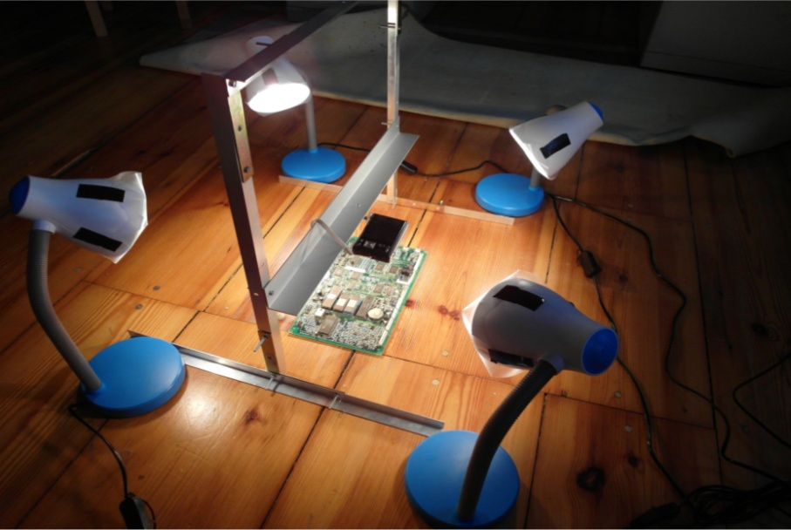

Figure : Image acquisition system

* Verzerrungen in bildern -> ausschnitt
* Schatten
* Winkel
* Kamera bewerten -> ausblick besseres kamerasystem
* Tiefenschärfe

## Classification results

Ef

## Optical character recognition results

Asd

# Life-cycle inventory analyses of printed circuit boards

Asdf

## Introduction

Safd

## Printed circuit board region classification based on electronic part recognition results

Sad

## GaBi-Software and LCI data availability of electronic components

Saf

## ILCD format for LCA-data exchange

# Conclusion and prospects

## Real time PCB board inspection

## Feature extraction based on Wavelet basis functions

dsf

# Appendix A

Table : Components in database

|  |  |
| --- | --- |
| Component name and description | Component image |
|  | C:\Users\WIN\Masterthesis\Masterthesis\Masterarbeit_daten\6.1\Bib1.png |
|  | C:\Users\WIN\Dropbox\Masterthesis\6.1\Bib2.png |
|  | C:\Users\WIN\Dropbox\Masterthesis\6.1\Bib5.png |
|  | C:\Users\WIN\Dropbox\Masterthesis\6.1\Bib6.png |
|  | C:\Users\WIN\Dropbox\Masterthesis\6.1\Bib7.png |
|  | C:\Users\WIN\Dropbox\Masterthesis\6.1\Bib8.png |
|  | C:\Users\WIN\Dropbox\Masterthesis\6.1\Bib9.png |
|  | C:\Users\WIN\Dropbox\Masterthesis\6.1\Bib11.png |
|  | C:\Users\WIN\Dropbox\Masterthesis\6.1\Bib14.png |
|  | C:\Users\WIN\Dropbox\Masterthesis\6.1\C1.png |
|  | C:\Users\WIN\Dropbox\Masterthesis\6.1\T1.png |